Course title:

The Post-Pandemic City

Rethink a new reality for urban life, drawing from your professional knowledge and personal experiences living through the pandemic.
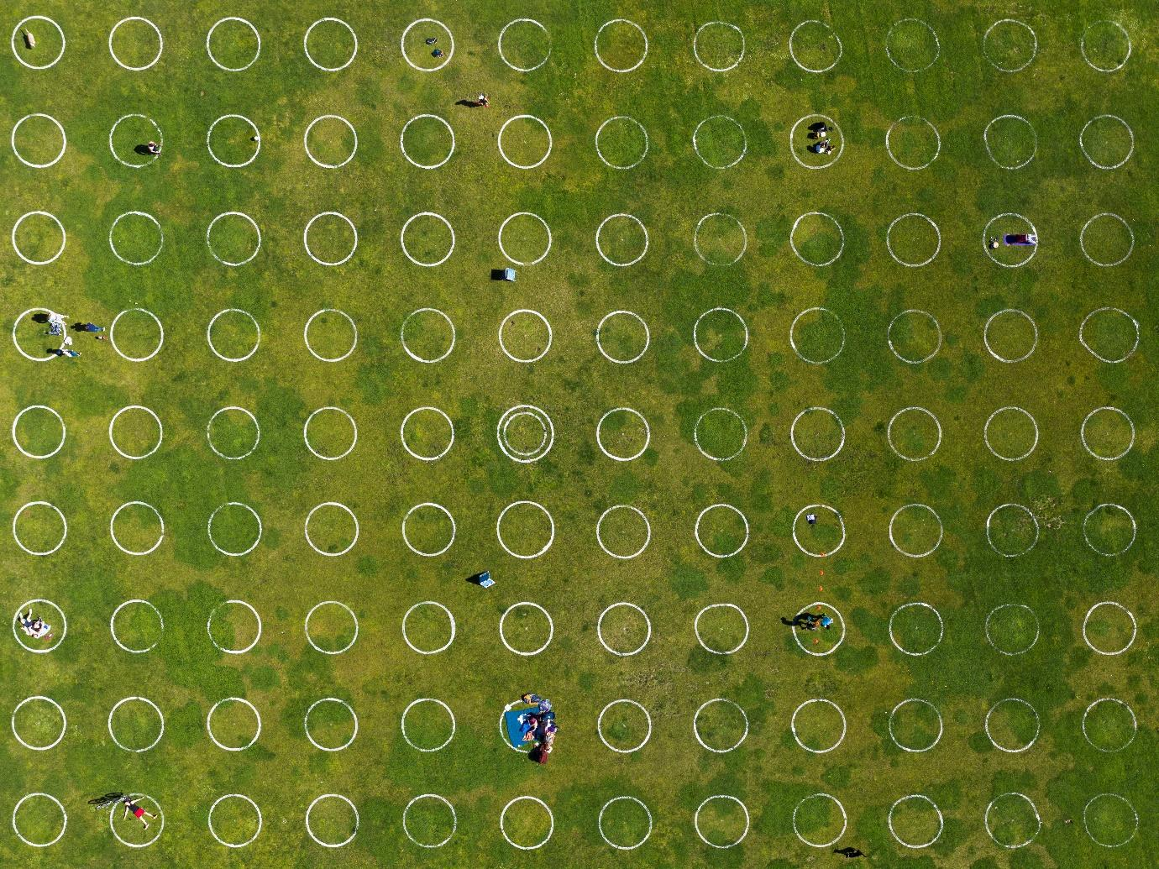
Course instructors: Zoltan Neville
Course code:
Course description:
Since December 2019, our way of life in cities has been impacted by COVID-19. Our fundamental understanding of interior and exterior spaces, social interaction, and daily habits have been questioned. However, since the industrial revolution architects, urban planners, and designers have attempted to improve our way of life as urban environments become more congested and our access to light, air, and nature is restricted.

This course is designed to reflect on our urban environment to create new realities for life that take into account these constraints, based on our collective experiences during the health crisis.

Students will work in multidisciplinary groups to rethink everyday spaces, places, situations, or objects that were most affected by the crisis, in an effort to reimagine an alternative urban future.

The course is open to BA & MA students of all disciplines, who have an enthusiasm for shaping the built environment.

Application: jóváhagyásos
Number of participants:
15
To work in groups of 3 or more students – Minimum 5 Architecture students (1 per group), Maximum 3 Theory students
Schedule:
13.40 – 16.30 Mon-Thur, 13.40-14.40 Fri
Outcome:
Open-ended design proposal, in 2D or 3D form, with an oral presentation per each group.
Prerequisite for completing the course:
General design software/skills, basic English language
Course recommendation
This course is recommended for students who are interested in shaping our built environments, using their respective professional skills and personal point of view.
It is not recommended for students who do not have any design production skill, or interest/awareness in spatial and urban environments.
Links:
https://www.latimes.com/entertainment-arts/story/2020-04-22/coronavirus-pandemics-architecture-urban-design
https://www.ft.com/content/95e19e1d-06c5-4b9e-bcb2-c73e8fe67c77
https://www.archdaily.com/940877/tactical-urbanism-reimagining-our-cities-post-covid-19

Readings:
(If there is a required or recommended reading related to the course, it can be entered here)

