Furniture design _Chair Transformation

ER-ARCH-BA-10-#1

MOHOLY-NAGY
University of Art and Design, Budapest
ARCHITECTURE STUDIO _BA1
2020

CONSULTANT: TAMÁS BENE benemome@gmail.com
TAMÁS MÁTÉ tamas@bivak.io

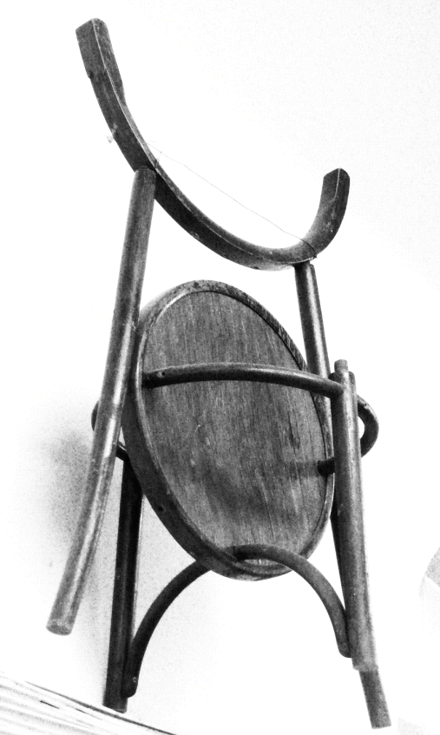

THE COURSE
THE LANGUAGE OF THE COURSE IS HUNGARIAN

In the furniture design education process the chair transformation is the first course. This is an introductory task of creating a new piece of furniture in an experimental and empirical way by using elements or parts of an old chair.

Student has to bring one used chair, and to dismount and rebuild it in a new way, in different form in the workshop. The approach is elastic, highlighting the importance of contextual origin and enabling the creative potential of random individual elements spontaneously thrown together. The process of personal action that leads towards making rather than hesitating.

