**Course Title: Screens of Identity: Unraveling Society and Culture through Israeli Films**

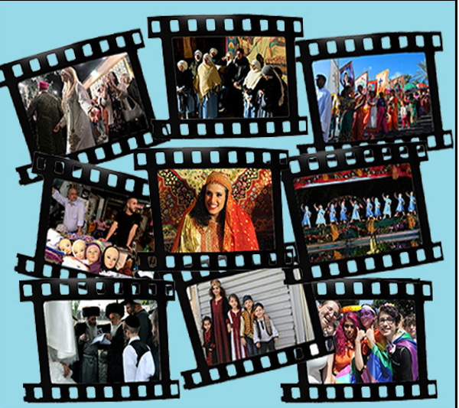

(In order to represent the course, an expressive image or graphic can be placed next to the title, the size of which is 1410x560 px, the format is jpg or png.)

**Course instructors: Dr. Orna Raviv**

**Course code:** B-KH-201-ELM-232402-04, M-KH-201-ELM-232402-04, M-KH-E-201-THEO-232402-04, ER-KH-201-THEO-232402-04

**Course Description:**

(The purpose of the course description is to arouse students’ interest and to provide some basic information in approx . 7-800 characters. Please indicate in each case whether the course is major specific or not, whether it is for BA or MA, or both. All course-week courses will be approved in order to maintain major proportions)

This course aims to introduce Hungarian students to Israeli cinema, exploring its historical, cultural, and artistic aspects. Students will comprehensively understand Israeli society through a selection of films representing different genres, themes, and directors.

The course will foster cross-cultural dialogue and encourage critical analysis, enabling students to appreciate how regional themes and local protagonists can also be relevant to Hungarian audiences. The course is for BA and MA students.

**Application**

**Number of participants: 30**

**Schedule:**

* Introduction to Israeli Documentary Cinema
* “First-person documentary”: The self, the political, and the social.
* Holocaust Films: The Problem of Representation.
* Holocaust Films: Second Generation of Trauma and Memory.
* Holocaust Films: Third Generation of Trauma and Memory.
* Introduction to Israeli Fiction Cinema
* War and Conflict: the representation of war and its impact on society.
* Israeli-Palestinian Cinema
* Religion on the screen: Modernity and Tradition meeting each other.
* Women films: Exploration of films focusing on women’s experiences and representation of gender roles.

**Outcome:**

A up to ten minutes video essay or 5-page paper about one of the subjects discussed in the course for the student’s choice.

**Prerequisite for completing the course:**

(The course is a criterion subject, it has no credit value, it ends with a signature)

Five points credit above completion of the course duties.

**Course recommendation**

The course applies to film or communication students and students arriving from geopolitics and international affairs studies, psychology, or sociology studies.

**Links:**

(If there is a web reference related to the course, it can be provided here)

**Readings:**

(If there is a required or recommended reading related to the course, it can be entered here)

Recommended reading:

Avisar, Ilan. “The National and the Popular in Israeli Cinema.” Shofar; an Interdisciplinary Journal of Jewish Studies, 24,1 (2005) 125-143

Burstein, Janet. 2013. “Like Windows in the Wall: Four Documentaries by Israeli Women.” Nashim; a Journal of Jewish Women's Studies & Gender Issues, 25. 129-146

Chyutin, Dan. 2003. “Introduction: Judaism and Cinema in an Israeli Context.” In *Hidden Light Judaism and Mystical Experience in Israel Cinema*. Wayne State University Press. Pp. 1-31

Dittmar, Linda. 2012. “In the Eye of the Storm: The Political Stake of Israeli i-Movies.” *The Cinema of Me: The Self and Subjectivity in First Person Documentary*. Edited by Alisa Lebow, Columbia University Press, 158-179

Kaplan Eran. 2011. “From Hero to Victim: The Changing Image of the Soldier on the Israeli Screen.” In *Israeli Cinema, Identities in Motion*.” edited by Miri Talmon and Yaron Peleg. Austin, University of Texas Press. 59-70

Loshitzky, Yosefa. 2001. “Surviving the Survivors: the Second Generation.” In: *Identity Politics on the Israeli Screen*. Austin: The University of Texas Press: 15-31.

Scham Paul. 2013. “Competing Israeli and Palestinian narratives” In *The Routledge Handbook on the Israeli–Palestinian Conflict*. Edited by Joel Peters and David Newman. New York: Routledge. Pp. 33-45

Skinazi, Karen E.H. 2023. The Religious Feminism in Rama Burshtein’s Romances. In Real Gender: Palestinian and Israeli Cinema. Sa'ed Atshan‏, Katharina Galor‏ (eds). New York & London: Bloomsbury. Pp 29-57.

### Steir-Livny, Liat. 2019. *Remaking Holocaust memory: documentary cinema by third-generation survivors in Israel*. Syracuse, NY: Syracuse University Press.

Peleg, Yaron. 2015. “On Shtisel (or the Haredi as Bourgeois).” Jewish Film & New Media: An International Journal, Volume 3, Number 1, pp. 113-117.

Raviv, Orna. 2020. Ethics of Cinematic Experience: Screens of Alterity. London and New York: Routledge.

Weiss, Shayna. 2016.“Frum with Benefits: Israeli Television, Globalization, and *Srugim*’s American Appeal.” *Jewish Film & New Media*, Vol. 4, No. 1, Spring., pp. 68–89.

Yaqub Nadia. 2018. *Palestinian Cinema in the Days of Revolution*. Austin University of Texas Press.