Dear students,

We have another exciting opportunity that you can consider applying for.

Are you an aspiring entrepreneur? Do you maybe have an interesting business idea or concept that needs support? Or maybe you don’t have an idea just yet, but you are motivated and willing to contribute your energy and diverse skill sets as part of a broader team?

If this sounds like you, then continue reading to discover more about the MOME Innovation Center’s Open Call for the Incubation Programme starting in March 2023.

Benefits include:

✅ Accessing funding opportunities for your project.
✅ Receiving personalised mentorship.
✅ Networking opportunities
✅ Developing your soft skills
✅ Access to design talent and research
✅ Access to campus infrastructure (including the TechPark)
✅ Interdisciplinary learning sessions with participants from different universities

Spots are limited, and you should apply here before the 28th of February 2023.

If you are interested to know more about the program, the benefits of joining, the incubation schedule, or maybe you want to potentially find new team mates (!!), then be sure to join our (hybrid) Info & Matchmaking Session.

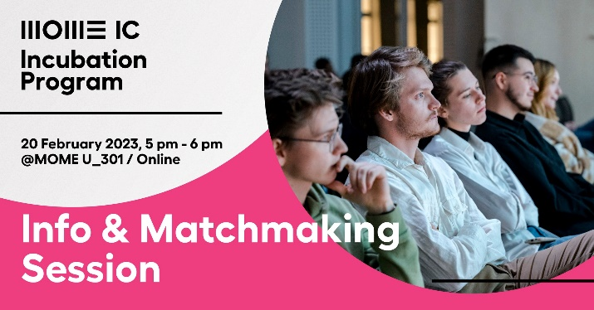

The event is taking place on 20 February 2023, from 5-6pm, at MOME’s UP Building (U_301).

The first part of the event is hybrid so you can also join online if you cannot make it in person, whereas the matchmaking part is fully in-person at the MOME campus: Budapest, Zugligeti út 9, 1121.

Agenda:
17:00 – 17:05. Introduction
17:05 – 17:20. Overview of the Incubation Programme
17:20 – 17:30. Q&A
17:30 – 18:00. Facilitated Matchmaking Session

Light snacks and drinks included.

